February 12, 2024 RE: YOUR CONTACT INFORMATION

Dear Valued Customer:
When trying to contact you recently, we discovered your email address on record here at our bank is invalid. Updating your contact information is a quick and straightforward way to help protect your account from potential fraud.

Please provide updated information by choosing from any of the below options:
- Call us at 888-415-5585.
- Stop by any of our 50+ convenient branch locations.
- Use the “Mail” option in the upper right-hand corner of Online Banking to “Compose” a secure message.

Our Customer Support Team is ready to assist you. Thanks for helping us keep you connected and your account secure!

Sincerely,
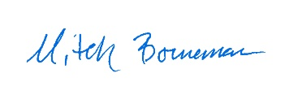
Mitch Borneman
Chief Operations Officer

Morton Community Bank is an Illinois Chartered Bank which includes
Clock Tower Community Bank and all your Hometown Community Banks

